Technical Architecture Document
AT4LEX
AT4LEX is an application to draft any plenary document produced at the European Parliament.
Purpose:
The goal of this document is is to describe the architecture necessary and sufficient for the execution of a project.

Table of contents
1. Description of architecture 3
1.1. Basic information 3
1.2. Network Architecture Schema 3
1.3. Software Architecture 3
1.4. Required Standard Runtimes 3
1.5. Non-standard server-side softwares list 3
1.6. Integration 3
1.6.1. Applications integration schema 3
1.6.2. Application integration criticality 3
1.6.3. System 3
1.7. Security 3
1.7.1. Authentication mechanism 3
1.7.2. Authorization mechanism 3
1.7.3. Specific confidentiality needs 3
2. Specific Development Tools 3
3. Annex - Document control 3
3.1. Circulation 3
3.2. Change history 3
3.3. Applicable documents 3
3.4. Reference documents 3
3.5. Glossary 3
3.6. Usage conventions 3
3.7. Procedure 'Technical Architecture' 3
3.7.1. Sending a Technical Architecture Document (DTA) 3
3.7.2. Validation of the DTA 3
3.7.3. STANDARDS support 3
3.7.4. HOSTING support 3
4. Other Annexes 3

Description of architecture

Basic information
This chapter describes the deliverables (applications, components, integration component) of the product in the EP's network using a synthetic schema.
Intranet | N
DMZ | N
VLAN dedicated | N
Internet access through the EP portal | N
Other | N

Network Architecture Schema
Insert a synthetic schema representing general software components in their respective network zones (application servers, applications, products, etc.), as well as their interactions and the protocols used for these interactions.

AT4LEX is the application that will allow the user the creation and the drafting of plenary documents. AT4LEX includes two main components: editor and dashboard.

The editor is based in AT4AMOS editor with some added services , these services are specific for EP:

Style management. Styles xml files will be stored in PURE-XML.

A layer to integrate with EPS/PURE-XML is also included. This will allow basically fetching and saving the documents.

The validation services will be able to detect TERMS (e.g. dates, names, references…) and perform spell checks by integration with a spell checker. (Hunspell).
Validation will be activate only by specific user actions (e.g. save) or automatic (e.g. backup) and performed at server side.

Standard term caching. User will be able to insert standard terms (country names, institutions names…). All these terms will be fetched from PURE-XML and cached to improve the performance.

The editor can be launch directly by other applications (e.g. AT4AM, DST, CAT4TRAD)

The AT4LEX dashboard will facilitate the creation (instantiation of documents), the management, security definitions and status changes. This dashboard it’s basically a set of datagrids showing the users different lists of plenary documents (new documents, recent documents, documents shared with me, documents managed by me, finalised documents….) and different possible actions (status change, edit, update from ITER, delete, share with other users…).

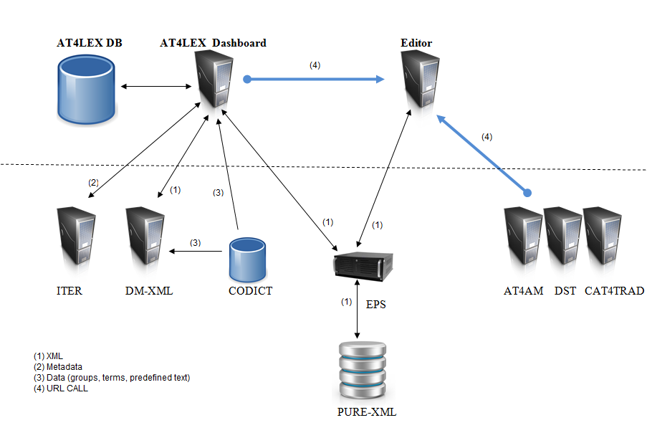
Figure 1: Network architecture diagram (EP Lan)

The network topology complies with the regular J2EE Intranet network architecture:
  - AT4LEX Dashboard Web application is hosted on an in-house J2EE server (Tomcat) and accessed in the Intranet via HTTP protocol
  - Authentication will be implemented using the standard JAAS (EPAUTH).
  - Role-based authorisation will be implemented, based on group membership (CODICT definition and AD)
  - The persistence layer is assured by in-house Oracle databases for data and PURE-XML repository for XML.
  - AT4LEX might send mails through a smtp mail server (intranet)
  - The Editor component is hosted in a separated Tomcat server.

Insert a synthetic schema representing general software components in their respective network zones (application servers, applications, products...etc), as well as their interactions and the protocols used for these interactions.

The AT4LEX application is composed of the following components:

Software Architecture
This chapter describes the software architecture according to the following schema:
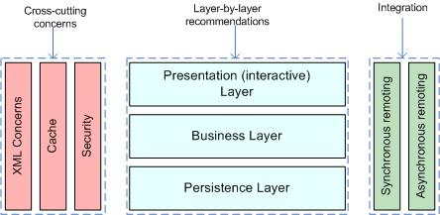

List the technologies/libraries used:
Client User interface (dashboard) | JQuery 1.8.0 or ExtJs
Client User interface (editor) | AT4AMOS
Server Presentation layer | JSP
Server Business layer | Spring 3.1.x (latest production release)
Server Persistence Layer | Spring Data 1.1/JPA / HIBERNATE 4.1.7
Db | Oracle 11
Synchronous Remoting (WS, RMI, etc.) | Spring MVC 3.1.x for Restful Web Services
Asynchronous Remoting (JMS, etc.) | HornetQ 2.2.x (client and hosting)
XML Handling | JAXP / StAX / TrAX  Spring OXM (Castor, JAXB)  XStream (for basic serialisation)
XSLT Processor | Saxon-HE 9.3 (for XSLT2 capabilities)
Cache | Ehcache 2.6.2
Security | Authentication EPAUTH over JAAS (ActiveDirectory)
Other | Jackson 1.9.11

Required Standard Runtimes
This chapter lists the various required server-side softwares (for example: Tomcat, HornetQ, etc.) and their runtime codes (allowing to map this document with multiple Runtime Hosting Request (RHR)).
List of required operational environment and associated 8 characters Code:
Existing  (Y/N) | Standard Runtime | Code  (8 char) | Environment(s)  DEV, ATE, PPO, FOR, PROD, INT
N | Tomcat 6.0.x, Java 1.6.0_45 | AT4LEXD | DEV,INT,PPO,PROD
N | Tomcat 6.0.x, Java 1.6.0_45 | AT4LEXE | DEV,INT,PPO,PROD
Please note that one separate RHR document will be needed for each new runtime.

Non-standard server-side softwares list
Please note that these non-standard softwares are most likely not to be accepted quickly, though may trigger special attention and dedicated handling. Fill in this chapter as accurately as possible.

Non-Standard Server-side software | Explanation of the need
GWT is used by AT4AMOS. | Inside the EP programme we will converge to a single GWT editor which will be used by At4AM, DST and AT4LEX. Today 2 different GWT applications are in PROD (AT4AM, DST)  AT4AMOS is the base of this single editor but some features will be included. (e.g. spell checker. Print, copy/paste)  That’s why in this DTA two components are defined: Editor (GWT implementation) and AT4LEX dashboard (not GWT).

Integration
This chapter describes integration of the product with other applications or services (Database, directory, etc.) and contracts and protocols used.

Applications integration schema
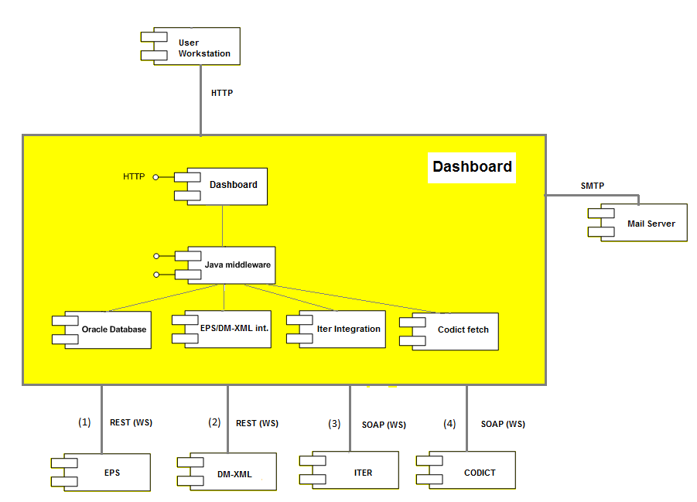
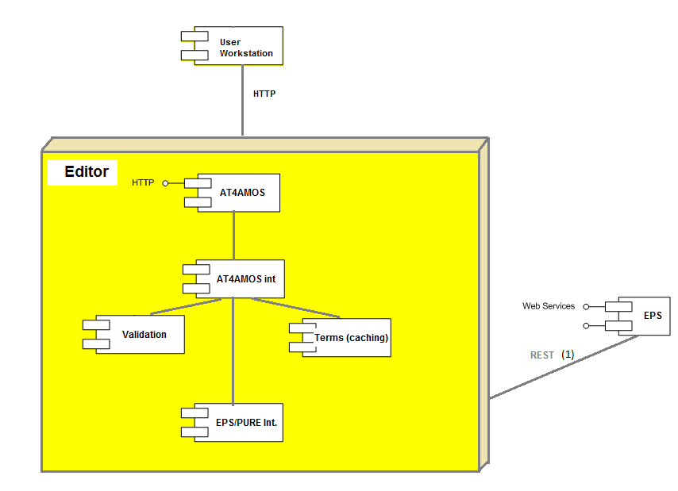
Figure 2: Applications integration schema

This section has to contain a schema describing interactions between applications. You have to precise the protocols used, and information needed to describe the exchanges (synchronous (remoting, web services), asynchronous (JMS, etc.).
Several e-Parliament projects can open via URL-call the editor. In this URL the needed parameters to identify the documents (UBI), users (UUI), templates (UTI) will be defined.

Editor can be called by but is not limited to:
- AT4AM
- DST
- CAT4TRAD
This section has to contain a schema describing interactions between applications. You have to precise the protocols used, and information needed to describe the exchanges (synchronous (remoting, web services), asynchronous (JMS, etc.).

Application integration criticality
Reference | Protocol | Synchronicity | Frequency | Business Criticality
PURE-XML/EPS (1) | WS | Synchronous | < 10/min | High
DM-XML (2) | WS | Synchronous | < 10/min | High
ITER-WS (3) | WS | Synchronous | < 10/min | High
CODICT (4) | WS | Synchronous | < 10/min | High

If the application cannot contact PURE-XML via EPS, some resources requested by the web service clients will not be accessible.

If CODICT services layer is not accessible, AT4LEX Dashboard will not work. The dashboard will not be able to check all the groups the user belongs (committee, political group, rapporteur, staff, assistant, Member…), but the Editor will continue to work.

Without ITER-WS and CODICT, the initiation of documents through DM-XML will not work.

Without DM-XML the Document instantiation/rendering will not work.

System

List of required system services
Database | Oracle 11
File system (direct access, sharing, FTP, etc.) | Direct Access
Directory (Active Directory, other) | N
Mails (sending mails from an application) | Y
Application Server | EP Tomcat 6.0.x
JDBC | Oracle THIN client
Other | N

System services schema (optional)
For clarity (and mostly if you have asked for multiple runtimes), please provide a schematic vision of the interaction between system services and applications.

Security

Authentication mechanism
The application’s users will login into application with EPAUTH mechanism, being validated against EP Active Directory.

Authorization mechanism
Basic role management through AD (….)
Three systems will be checked for authorization depending if the user is accessing to data (Oracle) or XML file (e.g. Editor component):

1- Main Authorization for coarse grained access is based on Active Directory roles (defining the user type eg: reviewers, drafter, initiators, General Administrator, Normal User, IPOL/EXPO admin, PRES admin)
2-Authorization based on PURE-XML rights (ACL definitions per XML document).
3-Authorisation for more fine grained roles which can not be maintained in Active Directory are with CODICT organisational groups (e.g. : AGRI, AFCO…)

- Used to authorize the operations at object level (change the status, publish, share…)
- Used to authorize if the user can edit, check-in, update the document (XML).
- Used to decide the objects accessible by the users . e.g. AGRI cannot access to AFCO documents.

Specific confidentiality needs
NONE

Specific Development Tools
The purpose is to mention only components which need a special or specific attention.
The STANDARDS Unit provides standard tools for the development of applications.

Mention here licence-limited tools you may need (restricted use product):
Oxygen XML | Y/N
Modelling tool UML | Y/N
 | Y/N

Annex - Document control

Circulation
DG or Company | Role | Name/Initials |  | RACI code
 | MOA-Sponsor | Olivier Leboeuf | OLE | C
 | MOA-Project Owner | Gianluigi Alari | GAL | C
 | MOE-Project Manager | Jesus Cerro | JCE | C
 | Key User

Change history
Version number | Status | Date | Initials | Summary of changes
1.0 | Draft | 15/06/2013 | JCE | First version
1.3 | Draft | 07/07/2013 | JCE | Lib review
1.4 | Draft | 05/02/2014 | BB | Lib review, switch to the new DTA template
1.6 | Approved | 17/02/2014 | BB | Changed 1.4 with the new TOMCAT env name for dashboard and editor

Applicable documents
Applicable documents are standards, specimen plans which need to be applied and whose application is verifiable.
N° | Document name | Description
[1] | Initial Risks Assessment | AT4LEX_IRA_EN_v0.2
[2] | Project Charter | AT4LEX_CHP_EN_V0.1
[3]
[4]

Reference documents
Reference documents are a help or a support but are not directly applicable (e.g. software reference manuals, sample files from outside firms, meeting papers).
N° | Document name | Description
[1]
[2]

Glossary
Abbreviation | Description
DTA | Technical Architecture document
RHR | Runtime Hosting Request

Usage conventions
Where a chapter or section is not considered to be applicable, put "NOT APPLICABLE". Feel free to insert new sections (chapter, paragraph) as needed.
Click on the Show/Hide button in the toolbar to display/hide guidance.
Guidance displayed.

Procedure 'Technical Architecture'

Sending a Technical Architecture Document (DTA)
The DTA and/or RHR(s) documents have to be sent to the IT correspondent of the DIT.

Validation of the DTA
As soon as the DTA is completely validated then the DTA is sent to HOSTING to continue the treatment along with one or multiple Runtime Hosting Requests (RHR).

STANDARDS support
During the project, STANDARDS can support the team project (MOA+MOE) but on request only.
STANDARDS provides relevant information (standard, methods) in the Quality Assurance Manual and the appropriate documents (templates) for the project.

HOSTING support
HOSTING deals with the DTA as soon as it is validated by STANDARDS.
HOSTING initiates a meeting with the stakeholders of the project in order to organise the technological environments necessary for the project.
For more information see OPERATIONS Website.

Other Annexes
You can change the title of the Annex and precise all information needed for the document.

Terms are used in XML4EP(akoma) to define metadata that can be reused in the verification, consistency check process across languages and translation process (automatic translation).
Used by DG TRAD in CAT4TRAD.
Sharing operation will only change the PURE-XML ACL and include a new set of users or groups.
AT4AMOS is based on GWT technology.
Runtime: for example: Tomcat, HornetQ, etc.
Environment (DEV, ATE (Applicative Test Environment), PPO, FOR, PROD, INT, etc.)
An identifier helping to point this relation in the Application Integration Schema
Frequency of the interaction (e.g. once every night for a batch, thousands of calls per minute if directly related to end user input or interaction)
PURE-ACL: When a user try to access a PURE-XML document (via EPS), PURE-XML checks the associated PURE-ACL and perform or not the action. This is the same for check-in/out operations, save..... In this case PURE-XML is performing the action, not AT4LEX. Concerning the Codict groups; these are filtering the information that the user can access. At the end AT4LEX will include these filters in the accesses to DB (queries)
R: Responsible, A: Approval, C: Contribution, I: Informed
Naming convention: Procedure 'Program & Project naming convention' (ICTASnet)
Status: Draft, Final, Approved
Description: Note, summary, link, etc.

